Internet Mapping and Information Processing
Instructor: Dr. Fang Qiu
Due Date: Next Week Before Class

Lab H3 ArcGIS API for JavaScript (2)

Tutorial:
Part 1: Adding widgets to web apps
In this exercise, you will use the Widget documentation from the API Reference to create and add several widgets to the MapView, position the widgets in the view, and execute the widgets from the web app.

In your web browser, go to the ArcGIS for JavaScript API Reference document (Quick Links | Core API Reference | ArcGIS Maps SDK for JavaScript) and search for the BasemapToggle class. Read the introduction for this class.
Hint: API Reference > esri/widgets > BasemapToggle.

Open ExerciseToggle.html with notepad++. Using the samples provided for the BasemapToggle class in the API Reference, write code to add the new widget to the web app.
- Import the BasemapToggle module:
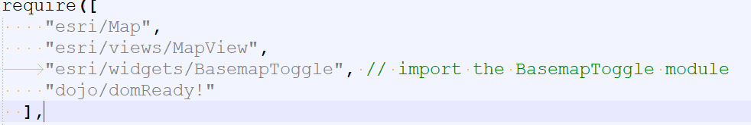
- Load the widget using the require function:
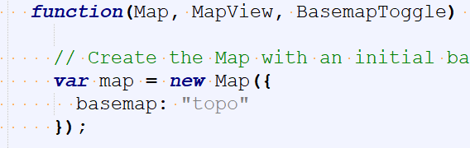
- Within the function, create the BasemapToggle widget:
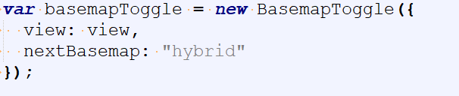
- Under the declaration of the basemapToggle variable, add the BasemapToggle widget to the view:
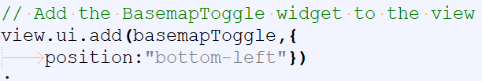

- Save your code and open it in your web browser to verify the new widget is available in the web app.

Homework H3a.html: improve your part 1 work to add a scalebar to your web app.

Part 2: Searching
In this exercise, you will use the Search widget documentation from the API Reference to configure the widget in a view. You will also enable suggestions to make searching intuitive and narrow the search results by limiting the number of results returned.

- Open ExerciseSearchWidget.html with your notepad++.
- In your web browser, go to the ArcGIS API Reference and search for esri/widgets > Search.
- Locate the documentation for sources property and find examples. Learn multiple sources that can be applied to the sources property and the JavaScript object used to hold multiple sources.
- Import modules.
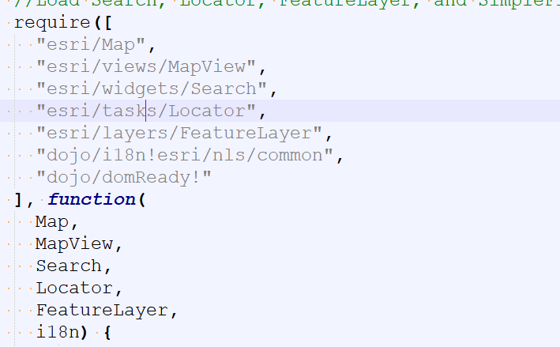
- Add a Locator source to the sources property. Url for the new locator: //geocode.arcgis.com/arcgis/rest/services/World/GeocodeServer

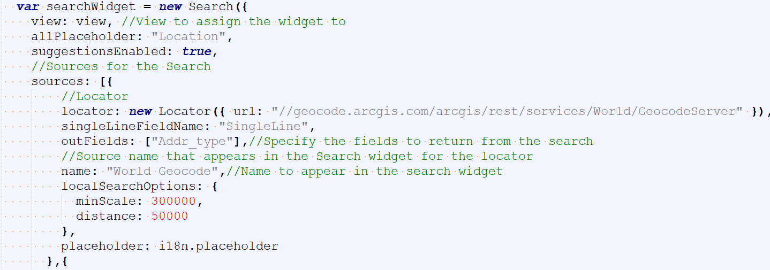

- Add a FeatureLayerSearch source to the search sources property. Url for the feature layer: https://services.arcgis.com/V6ZHFr6zdgNZuVG0/ArcGIS/rest/services/Alternative_Fuel_Stations/FeatureServer/0
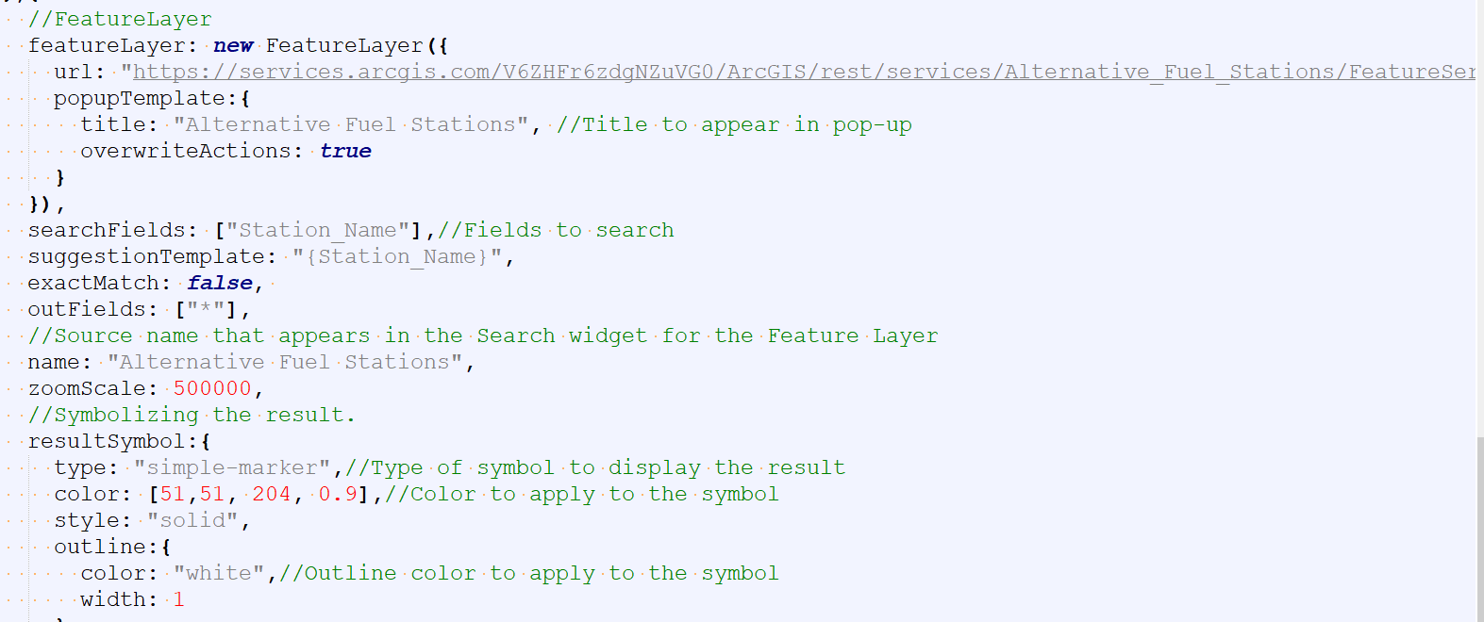

Homework H3b.html: improve your part 2 work to enable the suggestion property and set the maximum number of suggestions to 4.

Part 3: Select features
In this exercise, you will use the Query class documentation from the API Reference to write code to select features from a feature layer.

Step 1: Select features by attribute
- Open ExerciseQuery.html file with notepad++.
- Use https://services.arcgis.com/V6ZHFr6zdgNZuVG0/ArcGIS/rest/services/national_park_service/FeatureServer/0 as your feature layer. You will use the field names to select features from and for output fields later in this step.
- Browse to the Query class. API Reference > esri/tasks/support > Query to find our which property would you use to select feature by attribute.
- Add a clause to the where property. Set the Query class to return geometries and assign fields to be returned in the results to the outFields property.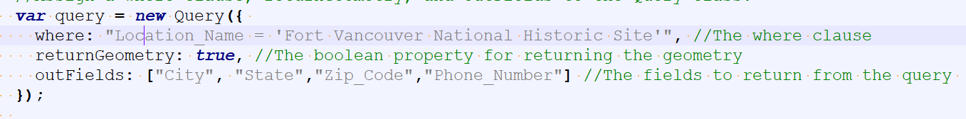
- Pass the results of the query to the displayResult function and generate proper console log.
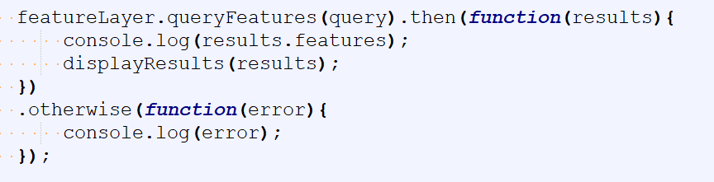
- Assign a symbol to the graphic using the displayResults function.
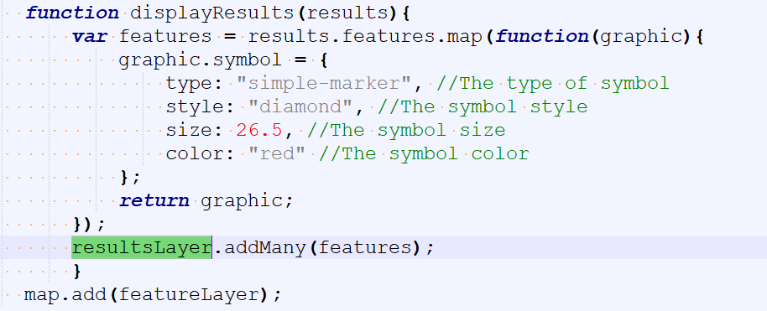
- Open the app in your web browser to verify that the queried feature is displayed. Save your html file.

Step 2: Select features by geometry
- Open ExerciseGeometry.html file with notepad++.
- Open the ArcGIS API for JavaScript API Reference and browse to the Query class. Find which property would you use the select features by geometry.
- Using the example for the geometry property in the API Reference, add a polygon geometry to the geometry property.
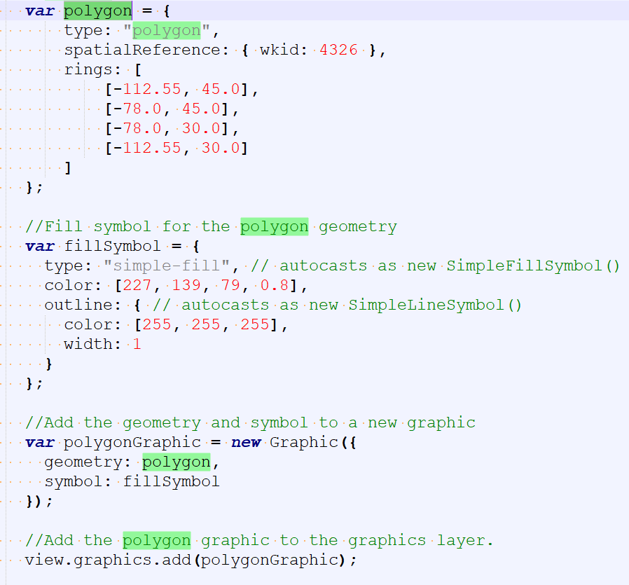

- Pass the results of the query to the displayResults function and assign a symbol to the graphic using the display function.
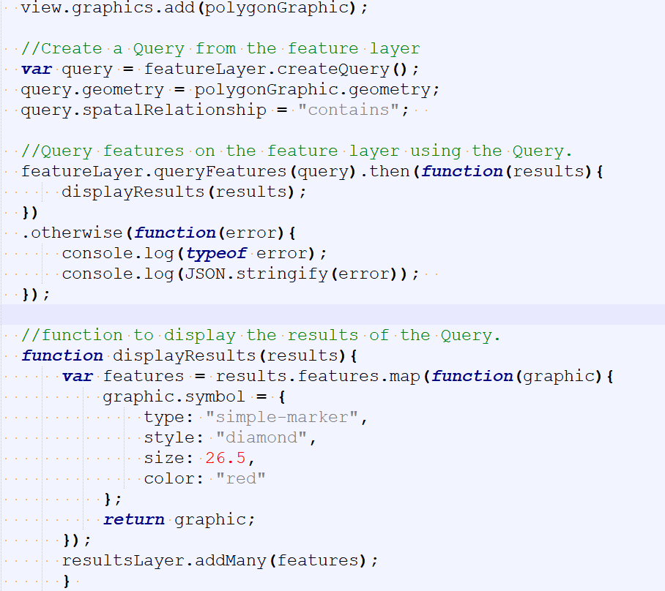
- Open the app in your web browser to verify that the queried feature is displayed. Save your html file.

Step 3: Select features from geoprocessing results
- Open ExerciseBufferGeometry.html file with notepad++.
- Open the ArcGIS API for JavaScript API Reference and browse to the Query class. Find which property would you use the select features by geometry. Search for the BufferParameters class, find which properties would you use to configure a buffer operation?
Hint: API Reference > esri/tasks/support > Buffer Parameters
- In the API Reference, locate the documentation for the GeometryService.
Hint: API Reference > esri/tasks > GeometryService
- Create code to perform a buffer operation based on a user’s map click position.
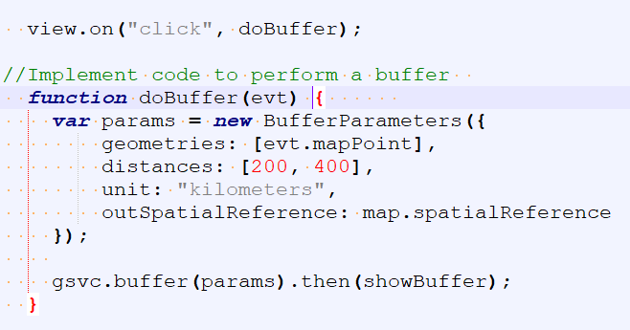
- Using the buffer’s geometry, select features from a feature layer that fall within the buffer geometry.
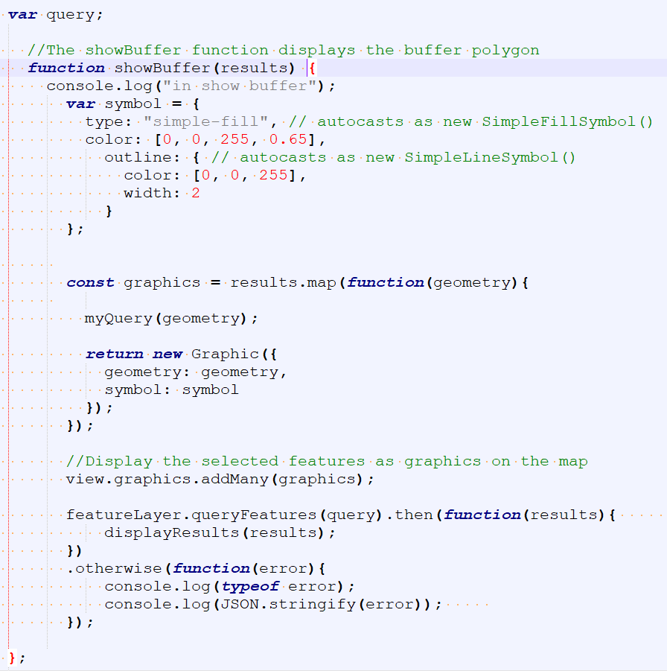
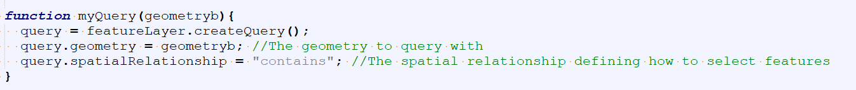
- Display the selected features as graphics on the map.
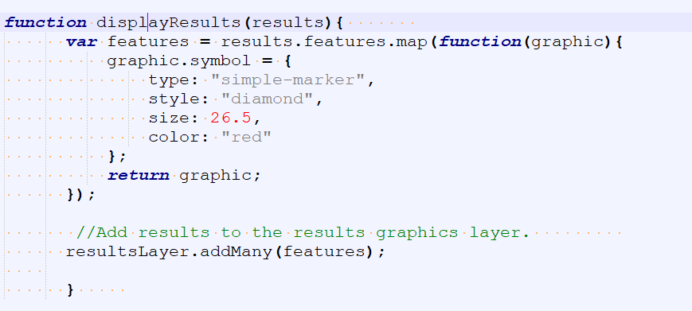
- Open the app in your web browser to verify that the queried feature is displayed. Save your html file.

Submissions:
- H3a.html
- H3b.html
- ExerciseQuerySolution.html,
- ExerciseGeometrySolution.html,
- ExerciseBufferGeometrySolution.html.

